CS 255 System Design Document Template

This template lays out all the different sections that you need to complete for Project Two. Each section has guidance to prompt your thinking. You will need to continually reference the interview transcript as you work to make sure that you are addressing your client’s needs. There is no required length for the final document. Instead the goal is to complete each section based on what your client’s needs are. Remove this note when you are finished, and replace all bracketed text with the relevant information.

UML Diagrams

UML Use Case Diagram
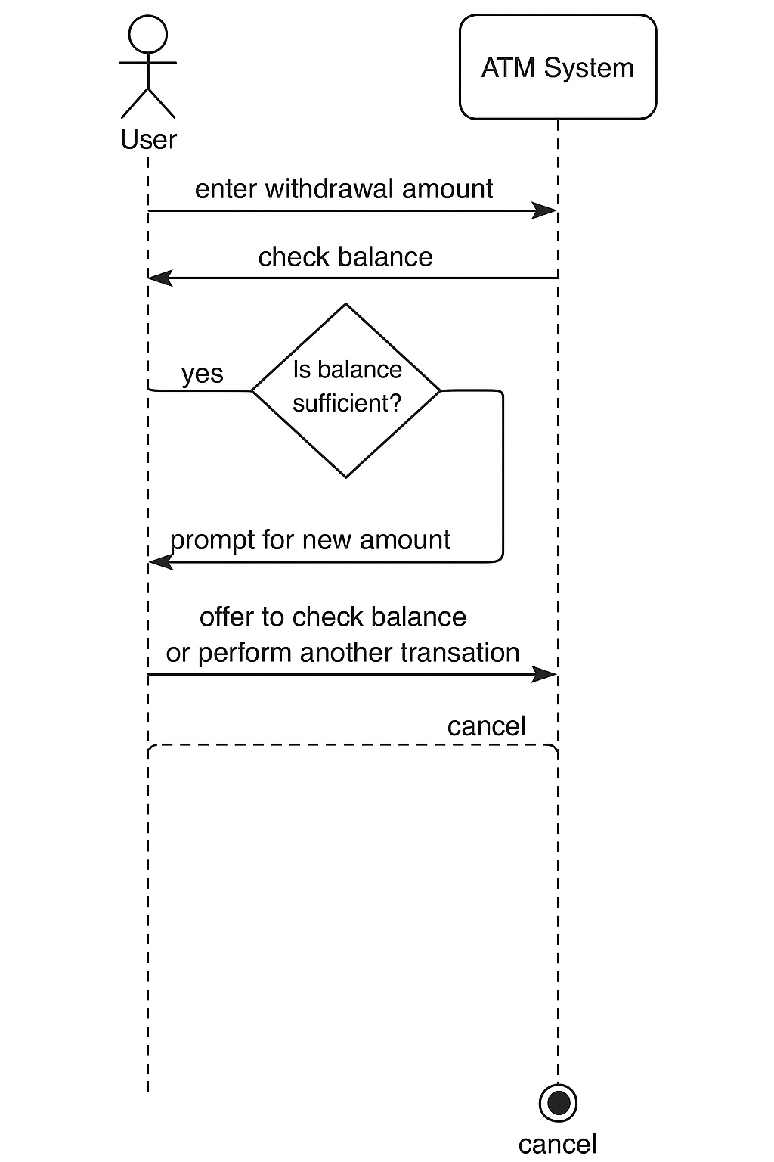

UML Activity Diagrams
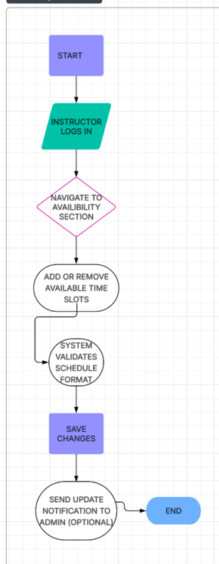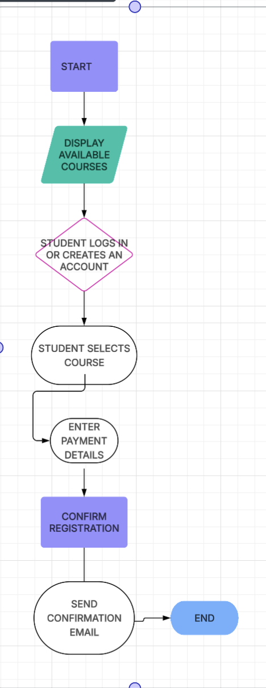

UML Sequence Diagram
Student → Web App: Open registration page
Student → Web App: Submit login credentials
Web App → Database: Validate credentials
Database → Web App: Return status
Web App → Student: Display course list
Student → Web App: Select course
Web App → Payment Gateway: Process payment
Payment GW → Web App: Return success
Web App → Database: Store registration
Database → Web App: Confirm success
Web App → Student: Show confirmation

UML Class Diagram
Key classes and their attributes:
- Student
  - studentID
  - name
  - email
  - password
- Instructor
  - instructorID
  - name
  - availability
- Course
  - courseID
  - name
  - schedule
  - cost
- Registration
  - registrationID
  - studentID (FK)
  - courseID (FK)
  - paymentStatus
Relationships:
- Student → Registration (1 to many)
- Instructor → Course (1 to many)
- Course → Registration (1 to many)

Technical Requirements

  - Hardware: Standard web server and database server. Recommended minimum: 8GB RAM, 4-core CPU, SSD storage.
  - Software:
    - Server: Linux-based OS (e.g., Ubuntu Server)
    - Backend: Node.js or Python Flask
    - Frontend: HTML, CSS, JavaScript (React or Vue preferred)
    - Database: PostgreSQL or MySQL
  - Tools:
    - Lucidchart (for design)
    - Git/GitHub (for version control)
    - VS Code or similar IDE
  - Infrastructure:
    - Cloud hosting (AWS, Azure, or Google Cloud)
    - HTTPS for secure communication
    - Role-based authentication system
    - Backup and logging systems for disaster recovery

